24CSI024-DATA STRUCTURES AND ALGORITHMS
UNIT 1-INTRODUCTION TO DATA STRUCTURES AND ALGORITHMS
Arrays and Array-Based Techniques (Two-Pointer, Sliding Window, PrefixSums) LAB WORKBOOK-09.07.2026

ROll-No : 25BAD123

CATEGORY: EASY

Question 1: Squaring a Sorted Array (Two-Pointer)
Anjali is processing seismic intensity readings stored in a non-decreasing sorted array. The readings can contain negative values (representing reverse-phase wave intensities) as well as positive values. To calculate the kinetic energy of these waves, she needs to square each value and return a new array containing the squares, sorted in non-decreasing order.
She must perform this operation in 𝑂(𝑁) time using the two-pointer technique:
- Initialize a left pointer at index 0 and a right pointer at index N - 1.
- Compare the absolute values of arr[left] and arr[right].
- Square the larger absolute value and place it at the end of the output array (starting from index N - 1 and moving backwards).
- Move the corresponding pointer (left inward or right inward) and repeat until the output array is filled.
  - The first line of input consists of an integer 𝑁 representing the number of readings.
  - The second line of input consists of 𝑁 space-separated integers representing the sorted wave intensities (can contain negative numbers).
  - Print a single line of 𝑁 space-separated integers representing the sorted squared values.
  - 1 ≤ 𝑁 ≤ 10000
  - −10⁴ ≤ 𝑎𝑟𝑟[𝑖] ≤ 10⁴
  - The input array is sorted in non-decreasing order.

Input 1:
codeText 5
-4 -1 0 3 10

Output 1:
codeText
0 1 9 16 100

Input 2:
codeText
4 -7 -3 2 3

Output 2:
codeText 4 9 9 49

Aim:
To square each element of a sorted array and return the squared values in sorted order using the two-pointer technique.

Pseudo-Code :

START

Read n
Read array

Create output array

Set left = 0
Set right = n - 1
Set index = n - 1

WHILE left <= right
IF square(arr[left]) > square(arr[right])
output[index] = square(arr[left])
left = left + 1
ELSE
output[index] = square(arr[right])
right = right - 1
END IF
index = index - 1
END WHILE

Print output array

STOP

C Program :
#include <stdio.h>
int main()
{
int n;
scanf("%d", &n);
int arr[n], result[n];

for(int i = 0; i < n; i++)
scanf("%d", &arr[i]);

int left = 0;
int right = n - 1;
int i = n - 1;

while(left <= right)
{
int leftSquare = arr[left] * arr[left];
int rightSquare = arr[right] * arr[right];
if(leftSquare > rightSquare)
{
result[i] = leftSquare;
left++;
}
else
{
result[i] = rightSquare;
right--;
}
i--;
}

for(i = 0; i < n; i++)
printf("%d ", result[i]);

return 0;
}
Output :
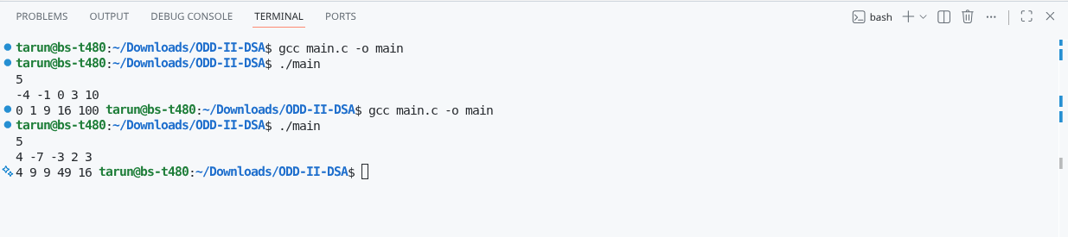

Question 2: Cumulative Resource Consumption (Prefix Sum)
Kabir is monitoring a data transmission line. He receives a log of data packets transmitted each hour over a period of 𝑁 hours. To generate an hourly usage report, he wants to compute the cumulative running sum of packets transmitted from the start of the log up to each hour.
Write a program that takes the hourly logs and outputs the prefix sum array representing the cumulative data volume.
  - Let the prefix sum array be P.
  - P[0] = arr[0]
  - P[i] = P[i-1] + arr[i] for 𝑖 ≥ 1.
  - The first line of input consists of an integer 𝑁 representing the number of hours.
  - The second line consists of 𝑁 space-separated integers representing the packets transmitted each hour.
  - Print a single line of 𝑁 space-separated integers representing the cumulative running sum at each hour.
  - 1 ≤ 𝑁 ≤ 10000
  - 0 ≤ 𝑎𝑟𝑟[𝑖] ≤ 1

Input 1:
codeText 5
10 20 5 15 30

Output 1:
codeText
10 30 35 50 80

Input 2:
codeText 3
0 0 5

Output 2:
codeText 0 0 5

Aim:
To find the cumulative (prefix) sum of the given array using the Prefix Sum technique.

Pseudo-Code:
START

Read N
Read array

Set prefix[0] = array[0]

For each remaining element
Add current element to previous prefix sum
Store the result in prefix array
End For

Print prefix array

STOP

C Program:

#include <stdio.h>

int main()
{
int n;
scanf("%d", &n);

if (n <= 0)
{
printf("Invalid array size.\n");
return 0;
}

int arr[n], prefix[n];

for (int i = 0; i < n; i++)
{
scanf("%d", &arr[i]);
}

prefix[0] = arr[0];

for (int i = 1; i < n; i++)
{
prefix[i] = prefix[i - 1] + arr[i];
}

for (int i = 0; i < n; i++)
{
printf("%d ", prefix[i]);
}

printf("\n");

return 0;
}

Output :

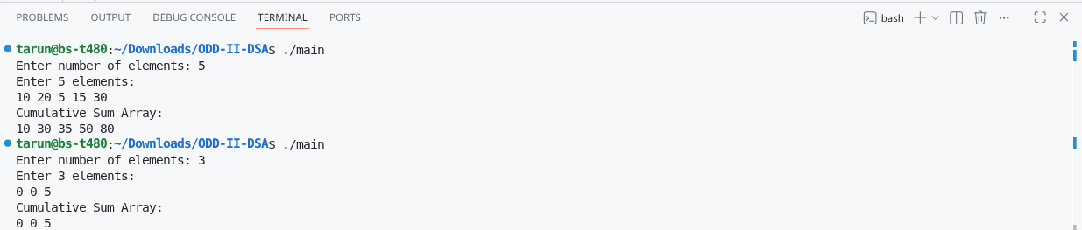

CATEGORY: MEDIUM

Question 3: Grouping Active Sectors (Fixed-Size Sliding Window)
Sam is working on a flash storage defragmentation algorithm. The sectors of the storage drive are represented by a binary array of size 𝑁, where 1 represents an active data sector and 0 represents an empty sector. To optimize read operations, Sam wants to group all active sectors (1s) together in a contiguous block.
He wants to find the minimum number of swaps required to bring all 1s together. This can be solved in 𝑂(𝑁) time using a sliding window:
- Count the total number of 1s in the array. Let this count be 𝐶. If 𝐶 is 0 or 1, no swaps are needed.
- Find a contiguous subarray (window) of size 𝐶 that contains the maximum number of 1s.
- The minimum number of swaps required is then 𝐶 minus the maximum number of 1s found in any window of size 𝐶.
  - The first line of input consists of an integer 𝑁 representing the number of sectors.
  - The second line of input consists of 𝑁 space-separated binary values (0 or 1).
  - Print a single integer representing the minimum swaps required in the format: Min Swaps: X.
  - 1 ≤ 𝑁 ≤ 10000
  - arr[i] is either 0 or 1.

Input 1: codeText 6
1 0 1 0 1 0

Output 1:
codeText
Min Swaps: 1

Input 2: codeText 5
1 1 1 0 0

Output 2
codeText
Min Swaps : 0
Aim:
To find the minimum number of swaps required to group all 1's together using the Sliding Window technique.

Pseudo-Code:
START

Read N
Read array

Count the number of 1's

If count is 0 or 1
Print 0
STOP

Count the number of 1's in the first window

Slide the window through the array
Update the count of 1's
Store the maximum number of 1's found
End While
Minimum Swaps = Total 1's - Maximum 1's in a window

Print Minimum Swaps

STOP

C Program :
#include <stdio.h>

int main()
{
int n;
scanf("%d", &n);

int arr[n];
int ones = 0;

for(int i = 0; i < n; i++)
{
scanf("%d", &arr[i]);
if(arr[i] == 1)
ones++;
}

if(ones <= 1)
{
printf("Min Swaps: 0");
return 0;
}

int current = 0;

for(int i = 0; i < ones; i++)
current += arr[i];

int maxOnes = current;

for(int i = ones; i < n; i++)
{
current = current + arr[i] - arr[i - ones];

if(current > maxOnes)
maxOnes = current;
}

printf("Min Swaps: %d", ones - maxOnes);

return 0;
}

Output :
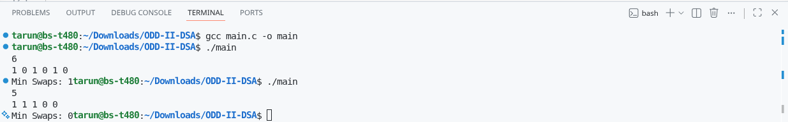

Question 4: Maximum Task Window Within Budget (Variable-Size Sliding Window)

Riya is scheduling a pipeline of processes on an embedded processor. Each process 𝑖 has a known energy cost arr[i]. The processor has a strict power limit 𝑃 for any contiguous execution sequence. Riya wants to find the maximum number of consecutive tasks she can execute without their combined energy cost exceeding the limit 𝑃.

She uses a variable-size sliding window:
- Maintain a start pointer at index 0 and a running sum of energy current_sum.
- Iterate an end pointer from 0 to N - 1 and add arr[end] to current_sum.
- If current_sum exceeds 𝑃,increment start and
subtract arr[start] from current_sum until current_sum <= P.
- Keep track of the maximum window size (end - start + 1) encountered during the process.
  - The first line of input consists of two space-separated integers: 𝑁 (the number of tasks) and 𝑃 (the maximum allowed energy consumption).
  - The second line of input consists of 𝑁 space-separated positive integers representing the
energy costs of the tasks.
  - Print a single integer representing the maximum consecutive tasks in the format: Max Length: X.
  - 1 ≤ 𝑁 ≤ 10000
  - 1 ≤ 𝑎𝑟𝑟[𝑖] ≤ 10⁴
  - 1 ≤ 𝑃 ≤ 10⁸

Input 1:
codeText 5 8
3 1 2 4 5

Output 1:
codeText
Max Length: 3

Input 2:
codeText 4 5
6 7 8 9

Output 2:
codeText
Max Length: 0

Aim:
To find the maximum number of consecutive tasks whose total energy cost does not exceed the given limit using the Sliding Window technique.

Pseudo Code:
START

Read N and P
Read array

Set start = 0
Set sum = 0
Set maxLength = 0

For each element
Add current element to sum

While sum is greater than P
Remove left element from sum
Move start forward
End While

Update maximum length
End For

Print maximum length

STOP

C Program :
#include <stdio.h>

int main()
{
int n, p;
scanf("%d %d", &n, &p);

int arr[n];

for(int i = 0; i < n; i++)
scanf("%d", &arr[i]);

int start = 0;
int sum = 0;
int maxLength = 0;

for(int end = 0; end < n; end++)
{
sum += arr[end];

while(sum > p)
{
sum -= arr[start];
start++;
}

if(end - start + 1 > maxLength)
maxLength = end - start + 1;
}

printf("Max Length: %d", maxLength);

return 0;
}
Output :

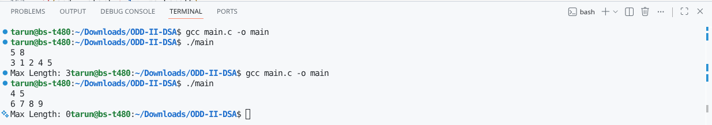

CATEGORY: HARD

Question 5: Sliding Window Maximum Peak (Monotonic Window Queue)
Rohan is building a real-time graphics rendering system. The system receives a sequence of frame rendering times. To smooth out frame drops, Rohan must calculate the peak (maximum) rendering time in every sliding window of 𝐾 consecutive frames.
To achieve an optimal 𝑂(𝑁) runtime, Rohan uses a monotonic double-ended queue (deque) to store indices of elements in the sliding window:
- As the window slides from left to right, maintain the deque such that indices of elements are stored in decreasing order of their corresponding values.
- For each element arr[i]:
  - Remove indices from the back of the deque if their corresponding values are less than or equal to the current element arr[i] (they can no longer be the maximum).
  - Insert the current index i at the back of the deque.
  - Remove the index from the front of the deque if it falls outside the bounds of the current sliding window (i.e., if the index is less than i - K + 1)
- For every step where the window is fully formed (when i >= K - 1), the element at the index stored at the front of the deque is the maximum for that window.

Note: Since standard C does not have a built-in deque, you can implement a basic deque using a pre-allocated array of size 𝑁 with front and rear pointer indices.
- The first line of input consists of two space-separated integers: 𝑁 (the total number of frames) and 𝐾 (the sliding window size).
- The second line of input consists of 𝑁 space-separated integers representing the frame
rendering times.
- Print a single line of space-separated integers representing the maximum value for each sliding window of size 𝐾.
- 1 ≤ 𝐾 ≤ 𝑁 ≤ 10000
- −10⁵ ≤ 𝑎𝑟𝑟[𝑖] ≤ 10⁵

Input 1:
codeText 8 3
1 3 -1 -3 5 3 6 7

Output 1:
codeText 3 3 5 5 6 7

Input 2:
codeText 4 2
4 3 2 1

Output 2:
codeText 4 3 2

Aim:
To find the maximum element in every sliding window of size K using a Monotonic Queue.

Pseudo Code:
START

Read N and K
Read array

Create an empty deque

For each element
Remove indices outside the window
Remove smaller elements from the back
Add current index to the deque

If window size is K
Print the front element of the deque
End For

STOP
C Program:
#include <stdio.h>

int main()
{
int n, k;
scanf("%d %d", &n, &k);

int arr[n];

for(int i = 0; i < n; i++)
scanf("%d", &arr[i]);

int deque[n];
int front = 0;
int rear = -1;

for(int i = 0; i < n; i++)
{
while(front <= rear && deque[front] <= i - k)
front++;

while(front <= rear && arr[deque[rear]] <= arr[i])
rear--;
rear++;
deque[rear] = i;

if(i >= k - 1)
printf("%d ", arr[deque[front]]);
}

return 0;
}
Output :
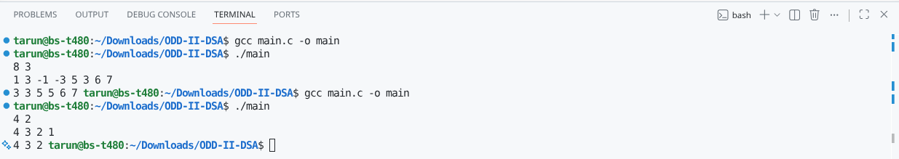

VIVA QUESTIONS:

1. How do we separate an ADT's interface and array implementation in C?
Answer:
An ADT defines what operations can be performed, while the array stores the data internally.
In C, we use functions to access and modify the array instead of accessing it directly.
This keeps the implementation separate from the interface.
2. Why doesn't the two-pointer technique miss the correct pair?
Answer:
The array is sorted, so moving the left or right pointer changes the sum predictably.
If the sum is too small, move the left pointer; if too large, move the right pointer.
No backtracking is needed because discarded pairs cannot satisfy the target.
3. Two pointers after sorting vs Hash Map in embedded systems?
Answer:
Sorting with two pointers uses less extra memory but takes more time.
A hash map gives faster searching but requires additional memory.
In embedded systems, two pointers are often preferred due to limited memory.
4. Why does variable-size sliding window fail with negative numbers?
Answer:
The sliding window assumes the sum always increases when expanding the window.
Negative numbers can decrease the sum unexpectedly.
Therefore, the sliding window logic no longer works correctly.
5. What is the update cost in a prefix sum array?
Answer:
Updating one element requires updating all following prefix sums.
This takes O(N) time.
For frequent updates, data structures like Fenwick Tree or Segment Tree are better.
6. What is passed when an array is sent to a C function?
Answer:
Only the address of the first element is passed to the function.
The entire array is not copied.
Therefore, sizeof() inside the function cannot determine the array size.
7. What runtime problem can occur with prefix sums?
Answer:
The running sum may exceed the maximum value of the integer type.
This causes integer overflow and incorrect results.
Using a larger data type like long long helps prevent this.
8. Fixed-size vs variable-size sliding window in a heart rate monitor?
Answer:
A fixed-size window is used to calculate the average heart rate over a fixed time.
A variable-size window is used when data depends on a threshold or condition.
The choice depends on the application requirement.
9. Why can we remove smaller elements from the deque?
Answer:
A larger incoming element will always be a better candidate for the maximum.
Smaller elements behind it can never become the maximum later.
Removing them keeps the deque efficient.

10. How do we extend prefix sums to a 2D image?
Answer:
We create a 2D prefix sum array where each cell stores the sum of all elements above and to the left. This allows sub-rectangle sums to be calculated in O(1) time.
It is widely used in image processing and matrix problems.

